Chapter 7
The Phinney Trigger Circuit

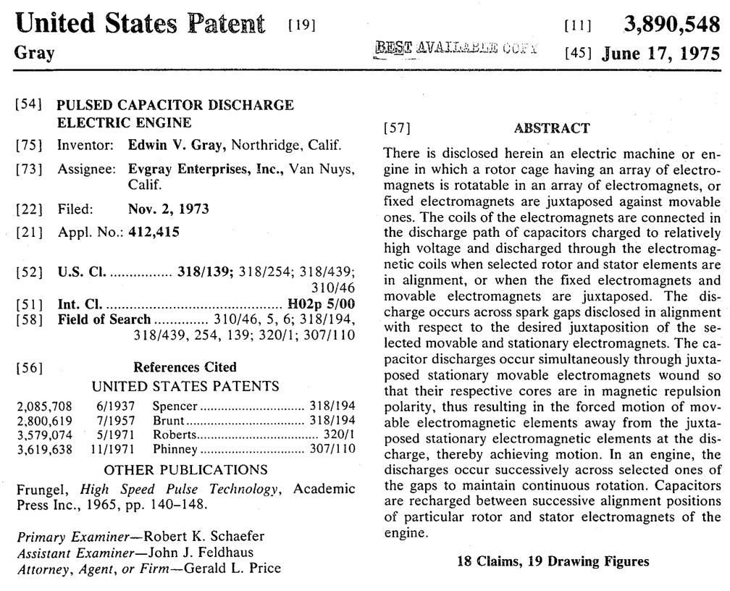
Consider the last listed Reference patent in E.V. Gray’s “pulsed Capacitor Discharge Electric Engine” patent cover (above). The fact that there are listed reference patents begs a fundamental question, “If Mr. Gray didn’t even know Ohms law, then how could he have researched a sea of patents to find those that related to his work?” Of course he didn’t - someone else did. Then there are three (maybe more) possibilities for the true source of this and the other listed reference patents.

1. The real inventor, Mr. Marvin Cole, had been working on this patent for some time and had collected information relevant to his design to be properly included in his application (which didn’t happen). When Mr. Cole left the project this partial document or file was left behind which Mr. Gray then “inherited”.

2. It has been said the Dr. Norm Chalphin was hired in 1972 to draft (or perhaps finish) these patent documents. He may have done his own professional search in an effort to provide good technical structure and legal foundation to this work.

3. The Patent examiner(s) may have added these reference patents as part of their search process.

If there is a slight chance that Marvin Cole had anything to do with composing this application then is behooves us to pay attention and review just what ever these other inventors had to say about their work and ideas.
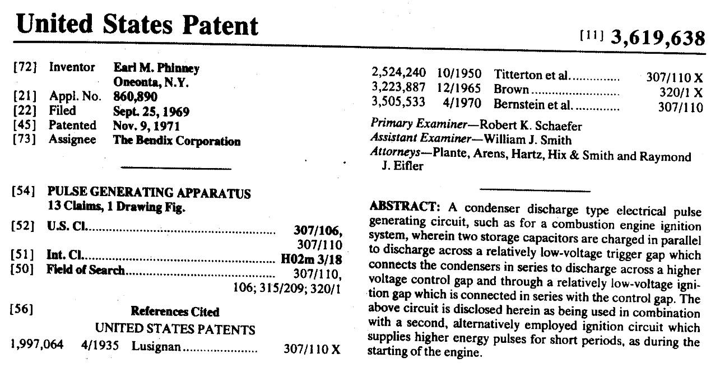

The date of acceptance on this patent raises some questions. If Mr. Cole had a chance to review it the day it was approved (which is unlikely due to filing delays and no Internet) then he really didn’t have much time to incorporate these concepts into the construction of the EMA4. The patent was approved in Nov. 1971 and we know that the EMA4 was doing performance demonstrations in Jan of 1973. So Marvin only had a year to take advantage of this possible technology improvement. One proposal would be that the mechanical part of the EMA4 was already largely constructed but Marvin was looking for improvements for his power supply system. Once he discovered this approach he quickly adopted it since there was not a whole lot of reconfiguring that would be necessary and it probably solved some of the problems he was facing.

What problems was he having? Well, there is some testimony that indicated that the early Pulse Motors were excited with Thyratrons (from Nelson Schlaft). This is very common application for classical motor speed control systems (like old elevators), but power hungry. The required heater filaments need hundreds of watts of continuous power. This was no serious problem for systems intending to operate from utility lines, but for a battery powered system is was the kiss of death. Yes, this was a powerful Free-energy Machine, but the OU output was largely in torque and only came on line at a certain minimum speed. There were probably problems with having a mechanical load (like a larger generator) sucking up the energy during the startup process. Once the engine was up to speed the energy would have been available, but all of the control systems needed to make a reliable transition from zero speed to operational speed were probably more complex than what could be engineered in the time span he was looking at. He already had startup problems from other aspects of the system. He still needed some approach that could do the HV discharge capacitor switching that didn’t require all the over head energy. When he was working with Pulse Motors this was not a problem. But now a Free-Energy engine that operated from a battery for the purpose of powering a car was a different matter.

If the above proposal is anywhere near correct, then the Phinney “Pulse Generating Apparatus” circuit is just what he needed. What this circuit was intended for was the ignition of jet engines, specifically ones that were cold and wet. Since the Bendix Corporation was the assignee of the patent it can be assumed there was an immediate aerospace application for this circuit. That’s not what Marvin needed, but what he probably saw was a quick high power trigger circuit. This design employed two spark gaps and had no need for a continuous heated power hungry filament. One spark gap acted as a trigger switch, while the other was intended to carry 90% of the actual load current. The down side was the need for two separate power supplies. However, Marvin already was using a number of unit power supplies as it was. He also had all of the necessary trigger contacts available, since these were being used to trigger the grids of the existing Thyratrons. All he probably had to do was make a few modifications to his existing power supply design and sell the Thyratrons at the local Ham Fest. (Actually they went into storage) He just might have been able to pull off this upgrade in the time slot mentioned. He also might have had friends that had advance knowledge of this circuit (or one like it), in which case he may have had a longer time to develop this approach.

For the sake of this Chapter we will assume he did indeed successfully eliminate the need for Thyratrons - because the design of the power supply disclosed in the Pulse Engine Patent has a lot in common with the Phinney circuit, which we will develop step by step.

The schematic disclosed by Mr. Phinney is pretty intimidating at first but it is well worth wading through it.

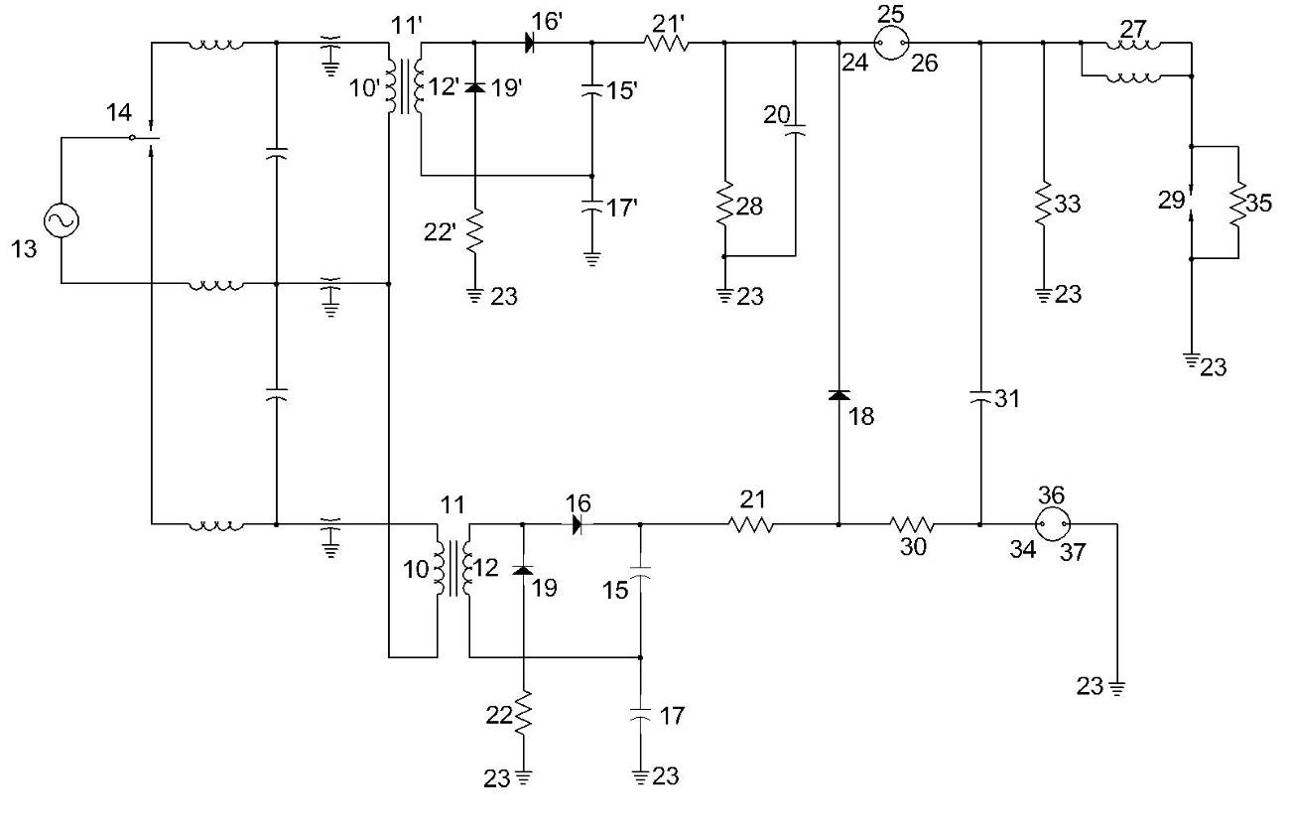
The above schematic is the starting point and is the only disclosed embodiment found in this patent. It’s probably better to have too much detail than not enough. Seasoned E.V. Gray researchers will quickly recognize the dual transformer architecture along with the symbols used for enclosed spark gaps. Everything to the left of resistors 21 and 21’ is part of the two required power supplies.
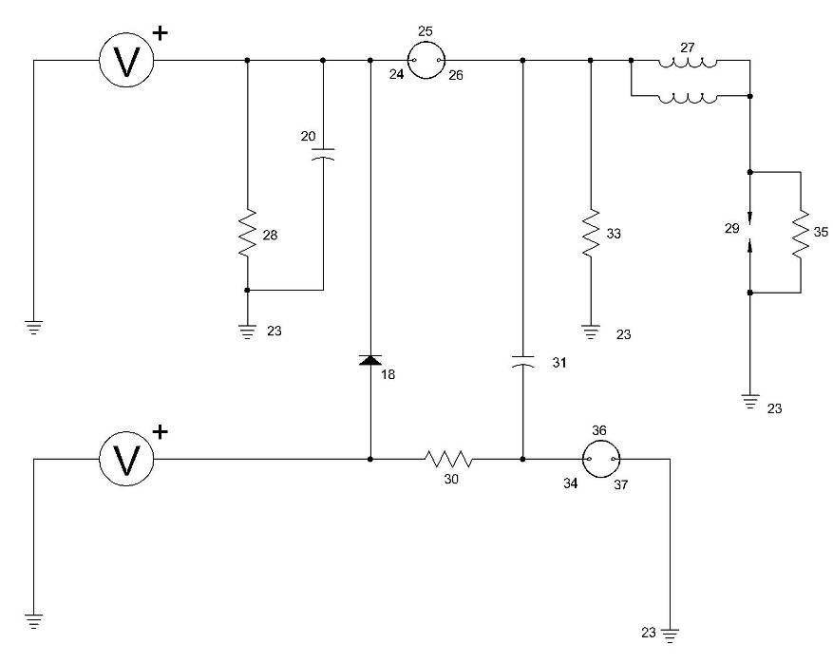
Let’s just eliminate the dated power supply designs and replace both of them with a couple of voltage sources. These could be any sort of “off-the-shelf” switch mode power supply module from eBay or any other workable circuit. Now the design is starting to get a little more manageable.

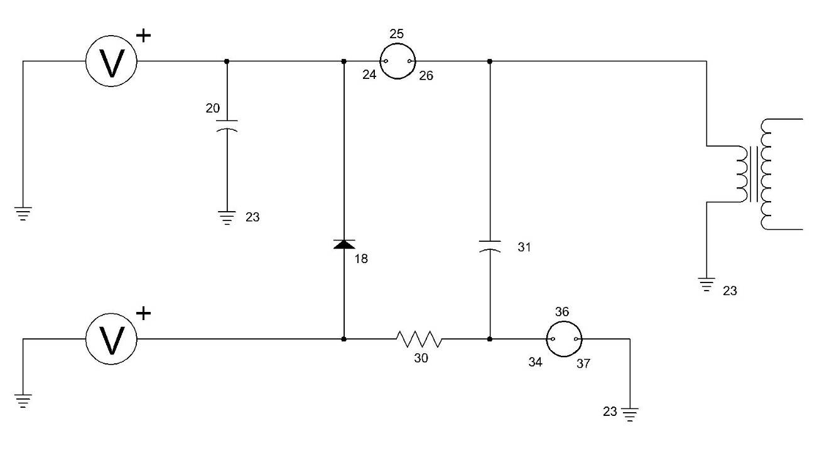
This is our second pass at functional simplification. Resistor 28 represented the storage capacitor leakage parameter for component 20. Modern HV poly capacitors can hold a huge charge for hours so we don’t need to worry too much about leakage resistance. Therefore resistor 28 was deleted.

Components 27, 29, and 35 are the modeled load for the igniter used in the jet engines. In our application we hope to drive the primary of a “Major” Free-Energy Engine electromagnet which is modeled here as a simple step-up transformer.

Resistor 33 was the means by which capacitor 31 became charged when the high resistance jet igniter was to be the intended load. In this application specific redesign we are now using the low impedance primary of a transformer as a load. With this connection capacitor 31 can easily be recharged through the primary winding’s ground path. Therefore resistor 33 was deleted.

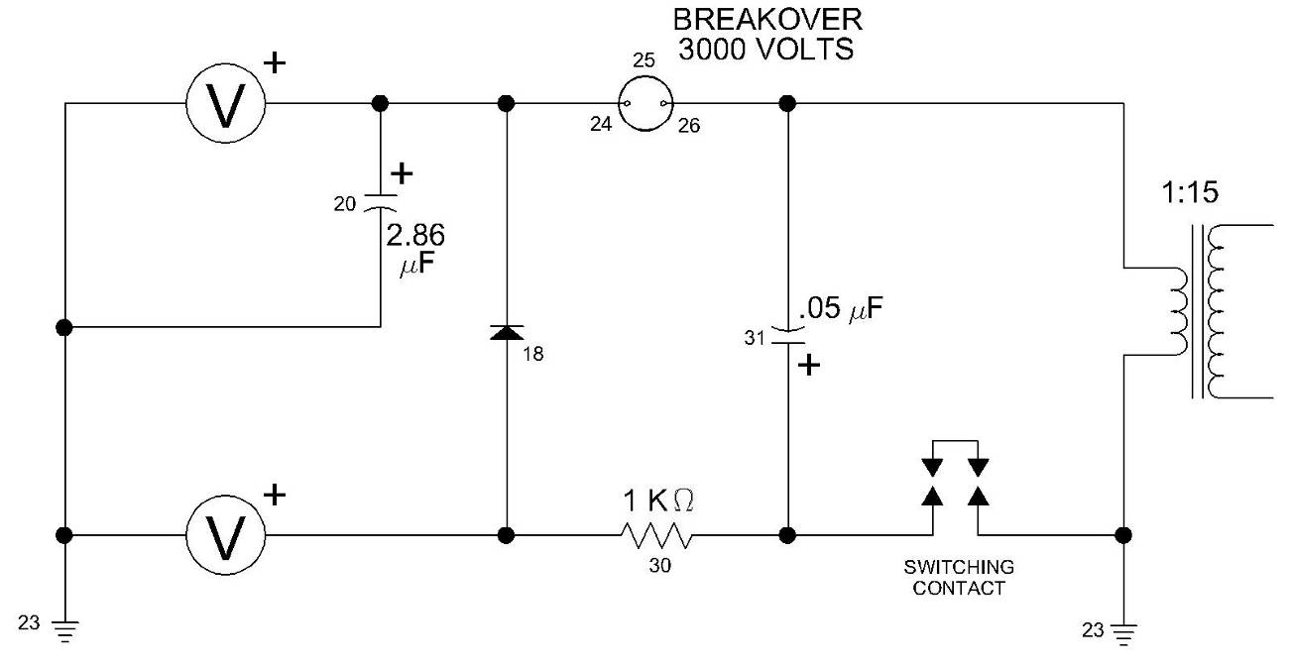
For Marvin’s application, he already had several mechanical contacts in his Engine to establish the proper timing of the desired trigger signals and therefore he didn’t need the lower calibrated arc tube that Phinney had used. It is interesting but, Mr. Phinney discloses in his patent actual component values that were probably used in his system. You don’t see this very much in modern patent applications, but it sure is an asset for us reverse engineers. These values have been added to the schematic above. Now we can better talk about how this circuit worked. (or at least what’s left of it)

Theory of Operation

The circuit starts with the arc tube (component 25) and the Switching Contact open. The upper voltage source changes capacitor 20 to its maximum value, while the lower voltage source charges capacitor 31 to its maximum supply voltage. If capacitor 31 should reach full charge before capacitor 20, then current will flow through diode 18 to assist charging capacitor 20. In practice both power supplies devote almost all of their output in charging capacitor 20. Once both capacitors are charged the circuit will sit in this condition indefinitely.

When the Switching Contact is closed capacitors 20 and 31 are connected in series (via the ground) thus the voltage drop across the Arc Tube is the sum of the supply voltages. If each supply voltage source is set at 2.5 KV then the Arc Tube will see 5.0KV. This value will immediately overvoltage the tube and it will breakdown. The stored energy in capacitor 20 is now presented with two current paths to ground. The first path is through capacitor 31, which has a small relative capacitance value. It saturates almost immediately. If the switching contacts remained closed then the flow of current through this path is quickly limited. This is a real functional asset for mechanical contacts. When the Switching contact does open there will be almost no contact arcing since the current is now blocked by the saturated capacitor 31, thus greatly reducing erosion of the contacts. The second path is through the primary of the step-up transformer. 90%+ of the energy in capacitor 20 flows through the Arc Tube while only a small fraction flows through the switching contacts.

Once capacitor 20 has discharged the Arc Tube eventually opens up and another recharging cycle begins. Resistor 30 allows the lower voltage source to recharge capacitor 21 over some period of time. During the discharge cycle resistor 30 limits how much current from the lower Voltage supply is allowed to escape to ground. The value of this resistor needs to be engineered to best fit the circuit operation.

Notice that capacitor 20 is 57 times larger than capacitor 31. This approximately means that only 1/57 of the energy stored in capacitor 20 is needed for the triggered switching operation.

Speculative Commentary

This is a neat circuit and it is somewhat similar to a two section Marx generator. But, like all electronic circuits this one has its limitations and tradeoffs. It seems well suited for this application, but Marvin had special existing circumstances that he could also take advantage of. First off he was attempting to switch a number of electromagnets with a number of unit power supplies. Instead of having to have separate triggering voltage sources why not use his other existing powers supplies for double duty. One power supply could charge its own storage capacitor and also provide a small amount of energy to charge the triggering capacitor in an adjacent power supply. This circuit seems to be able to accommodate this kind of modification.

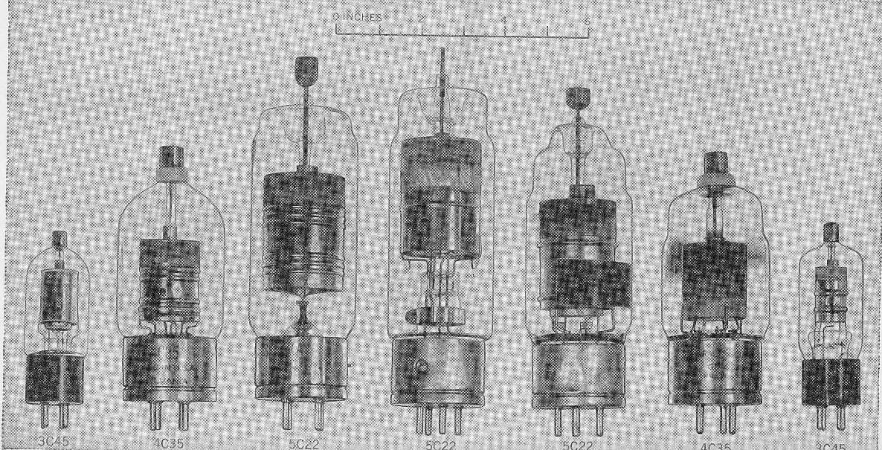
These are samples of glass Thyratrons of the 40’s from “Pulse Generators” Radiation Laboratory MIT 1948. Models used after this, even in modern times have not varied a whole lot from what is shown. The author just finished a project (2011) at a loca1 hospital where an array of 12 each thyratrons similar to the model 3rd from the left above are still being used for elevator service.
The Thyratron is a variation of a thermionic vacuum tube triode. It has a control grid that determines when the tube will “fire” based upon the applied voltage. Essentially it is a controlled arc. Once the Thyratron “fires” the grid no longer has any control. The tube conducts until the power is removed. The glass envelop contains an atmosphere of hydrogen or mercury vapor.
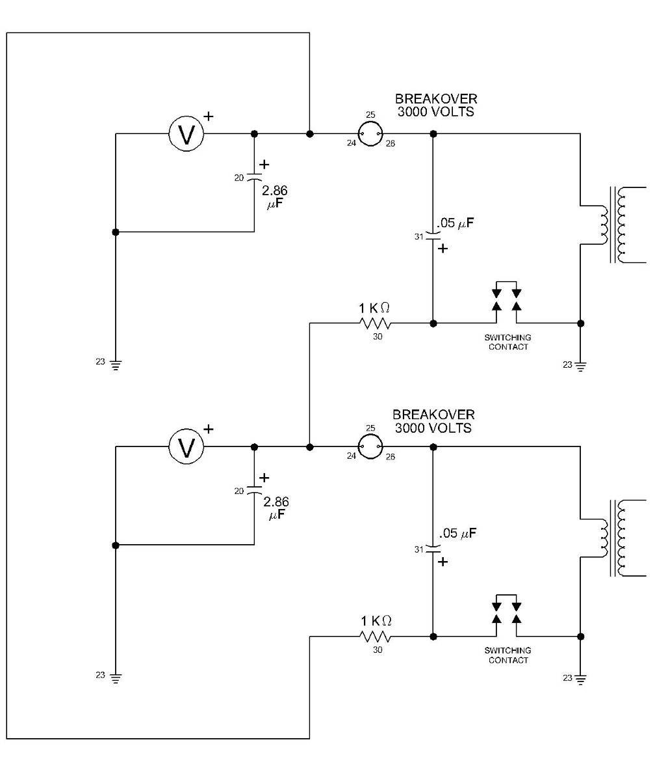

With two loads and two equal voltage sources the Diode (component 18) is no longer needed since each storage capacitor has its own voltage source. This proposed schematic is rather bulky. Let us turn the bottom circuit upside down and then do some clean up.

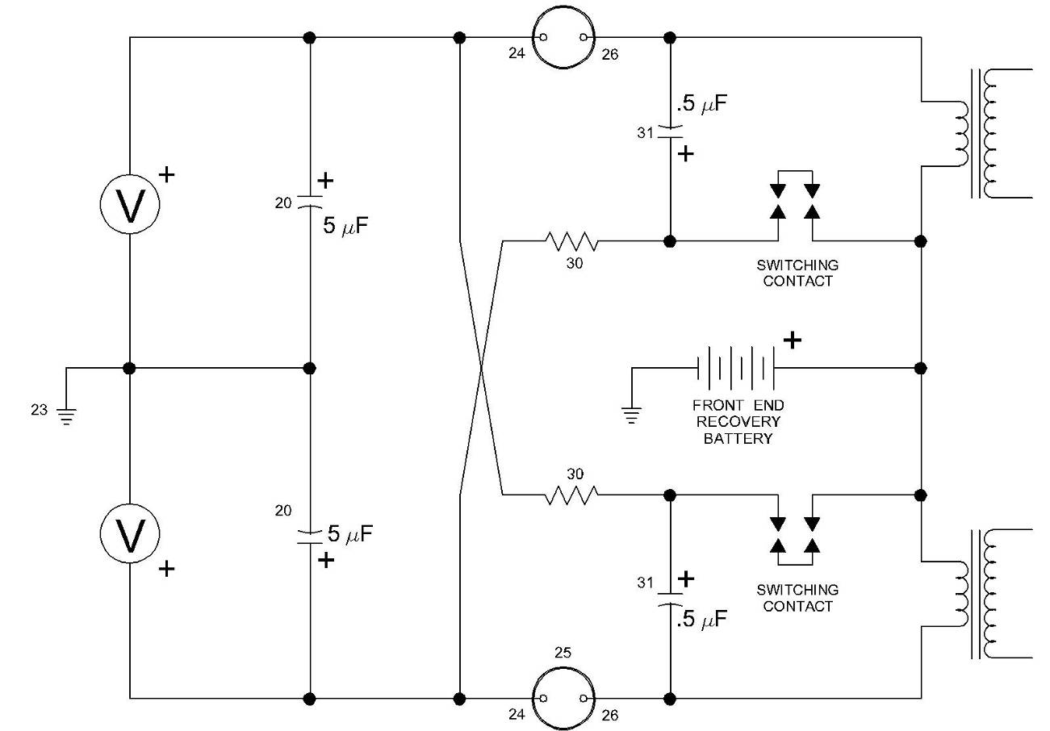

Now we have a circuit that can switch two loads with low current triggering methods using one power supply per main storage capacitor. If we desire to recover some of the returning pulse current we can place our wet cell battery in the return ground path – like Marvin Cole appears to have done. This speculated circuit is probably pretty close to what was done in 1971-72 without using Thyratrons. Today, we have greatly improved solid state devices (SCR’s), with which we can do it a lot better (providing that the speculated “Radiant Energy” doesn’t destroy them).

The purpose of this exercise was to attempt to establish where some of the disclosed E.V.Gray circuits might have come from. We will never know for sure, but consider what this circuit would have looked like if you wanted to hide its novel low energy trigger operation - yet have enough circuit left over to be believed by a patent examiner. One approach would be to remove all the low energy triggering components and just leave those devices that dealt with the main current flow.

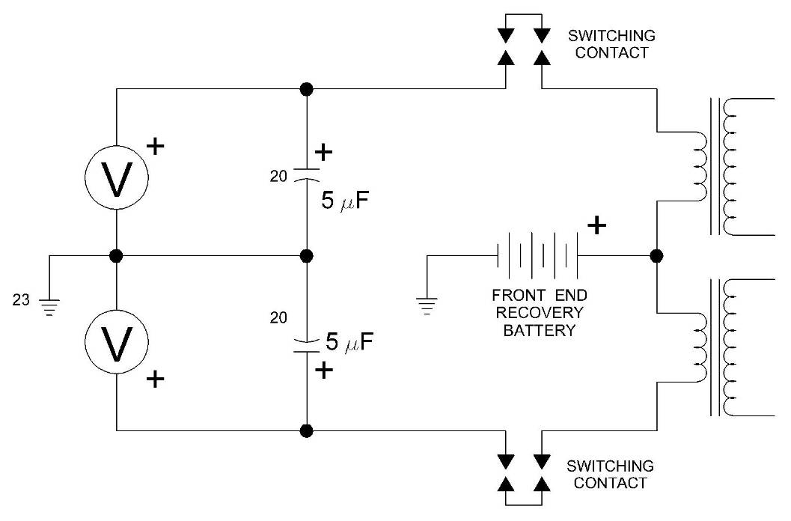
The above schematic might be one such version of an attempt to do a little non-disclosure editing prior to a patent application. There are probably several other variations that could have been developed, but this one has a special interest to us.
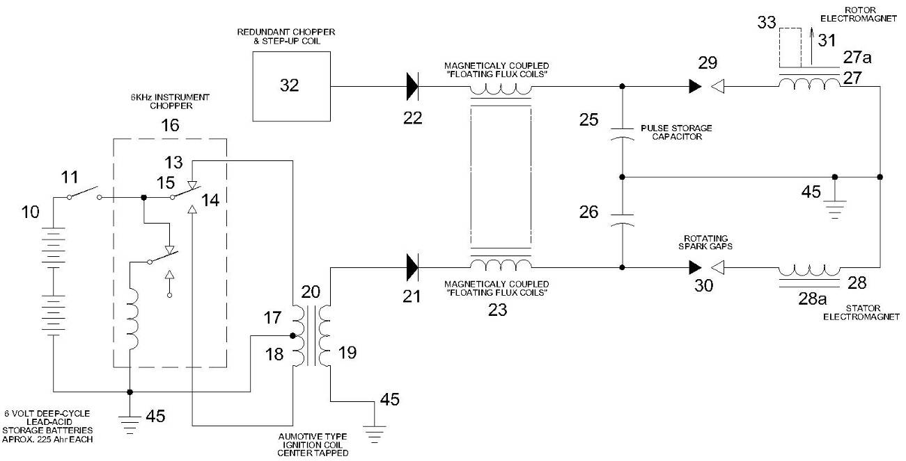

Consider the power supply schematic disclosed in the E.V. Gray Pulse Engine Patent. The “Magnetically Coupled Floating Flux Field”, for now, is considered to be part of the power supply and is proposed to be primarily intended to protect its ignition transformer from the non-classical electrostatic harvest pulse that recharges the main storage capacitor. (See Chapter 6)

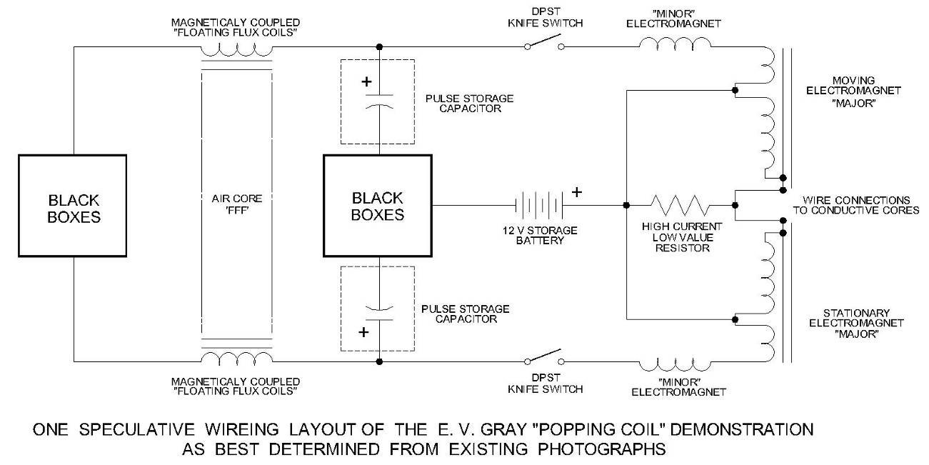

Or consider the component layout of the various “popping Coil” demonstrations (described in Chapter 5)

This author contends that the removed Phinney triggering circuit feature left an odd backbone of components that don’t make a whole lot of engineering sense. The back to back storage capacitors layout has caused this reverse engineer heart burn for years. The question has always been “Why two power supplies?” It was a good question and the proposed answer is that the Phinney triggering circuit was removed from the original Marvin Cole schematic to create the disclosed patent schematic, but somehow the source reference patent for this technology was overlooked during the editing process. This idea is just one speculated solution to explain the available information. We are sure that others can come up with equally valid proposals given the limited information there is to start with.

Not only was the Phinney trigger circuit removed from the patent application but it appears to have been removed from later “Popping Coil” apparatus as well. This author contends that the original “Popping Coil” demonstration setup built by Marvin Cole was far more impressive than the dumb down version employed by E.V.Gray and Richard Hackenberger. This is based upon a review of the money flow. How was Marvin Cole able to get funding to build not one but five very expensive Pulse Motor prototypes? He had to have something very impressive, besides a notebook full of drawings and theories, to convince well off investors to fund this project. Perhaps his first prototype motor, that he financed himself, worked well enough to inspire investment? (Which we doubt) Or did the “Popping Coil” demo work well enough to allow the moving coil to hit the ceiling with considerable force? Something was demonstrated that made believers of conservative investors with technical knowledge. We sincerely wish that we could have been there to see it.

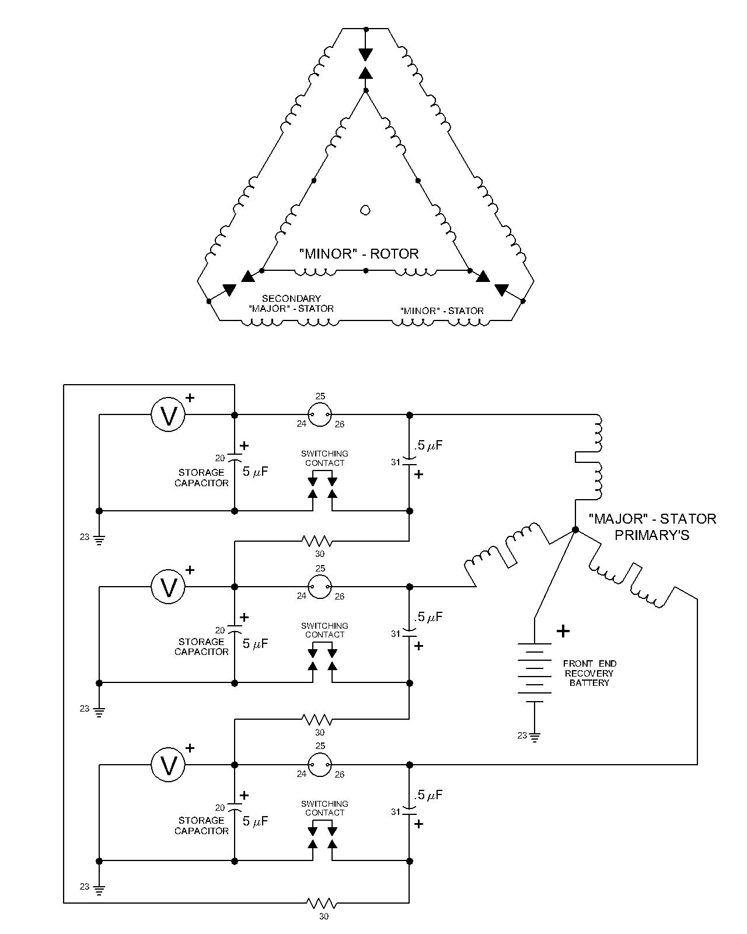
This partial schematic is another proposed speculation design that combines the Phinney Trigger circuit with the Delta wiring topologies discussed in Chapter 4 for six “Major” and six “Minor” electromagnets. Again this is only a partial design dealing with a more complete excitation plan for the “Major” and “Minor” electromagnets as they might have been wired for the non-classical energy creation cycle. It is proposed that the OU is generated in the stretched arcs shown in the electrodes of the upper delta circuit. All of the energy flow here is considered to be “classical” and can be engineered as such. The non-classical event takes place when the arcs are quenched.

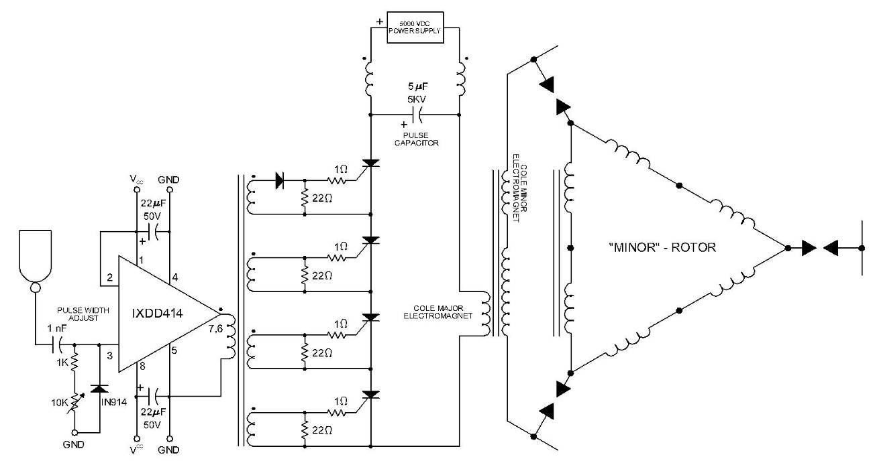

This is a partial schematic showing how a more modern approach would be explored to provide the excitation pulse to the “Major” electromagnets. The SCR’s shown would require a PIV of at least 1600 Volts (with 2400 Volts being even better) at a nominal continues current of 100A. At the pulse widths anticipated that could easily handle 400Ampers. This is not the optimum circuit that can be designed, but it is cost effective. It may not be as fast as a triggered arc (approximately 15 nS) but not bad at 150 nS. Its real advantage is in its timing resolution which is far more accurate than a mechanical trigger approach. This design can be fired using TTL voltage levels which will allow for the use of microprocessor inputs to determine precise triggering commands.

Only one “Major” primary is shown in this example. It is believed that there is ample current capacity to be able to excite three transformers in parallel.

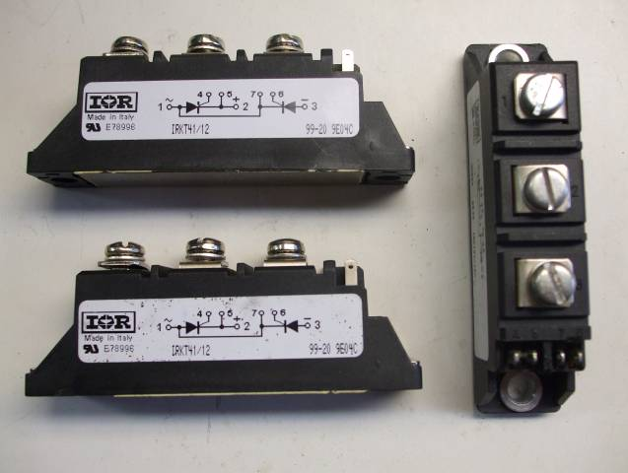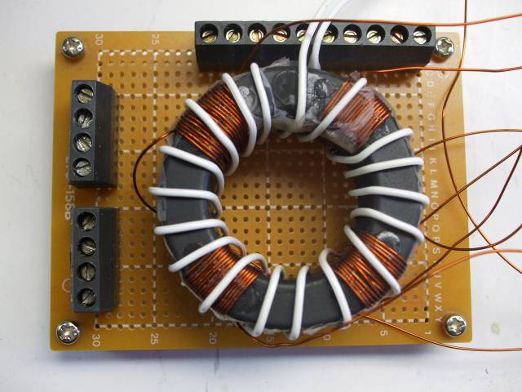
Samples of HV SCR’s to be used in more modern Four Channel custom Pulse Transformer used for
Pulse circuits to drive replication Marvin Cole Free- triggering a series string of SCR’s. It is driven by an
Energy designs IXDD414 chip.

